Test Number | Test Case Type | Description | Test Steps | Test Data | Expected Results | Actual Results | Status (Pass/Fail)
1 | Functionality | Testing to see utility bill reference number validation when creating customer, using incorrect inputs and then using a correct input and finalising the creation of the customer and viewing the program having accepted their information. | Create a customer, insert two invalid inputs, null value and 1 character length input, then correct input and finalise creation of customer with viewing of the program having accepted the last address input. | Option “2” sign up customer.  Option “1” continue sign up.  Name as “John Helix”, nation id “AA123123B”.  Option “1” for passport identification, “123123123” as photo id number.  Option “1” for utility bill.  Entering “ “ (null value) as utility bill reference number.  Entering “1” as utility bill reference number.  Entering “123456” as utility bill reference number.  View customer details then option “1” to confirm changes. | The program should allow for correct creation of customer, allow type of address selection of utility bill, when inserting two incorrect inputs; program should state the type of error occurred and prompt for a correct number, then when inserting correct value, program should allow creation of customer and viewing of that customer. | The program worked as expected allowing correct type to be selected, correct error messages based on incorrect input, then allowing correct input to work and viewing of that input during confirmation of customer. | Pass
2 | Usability | The logs.txt file should show each action performed during the running of the program, using the actions taken from test number 1 and manually opening the logs.txt file to see the trace with timestamps being chronological top-down format. | Open logs.txt file from IDE to view the contents and verify chronological order of logs and the correct steps taken from test number 1. | Open “logs.txt” and view contents. | The logs.txt file should show the actions taken in test number 1, in a chronological order with correct time stamps top-down format. | The test went as expected opening and viewing of the logs filed verified the actions taken in test number 1. | Pass
3 | Functionality | Testing the robustness of the generated account number, using already existing customer profile from the creation that occurred during test number 1 for ”John Helix”, ensuring accounts have a 8-digit number that is distinct, so creating multiple accounts with that customer, 2 of a single type and then 1 of a another type just confirm the same type also has uniqueness, then view all accounts and comparing the results for randomness, checking for duplication and chronological generation, making sure an account number cannot be guessed based on the order it was created. | Run the program, “John Helix” as the customer profile, open 2 personal accounts, 1 ISA account, then view all accounts and compare account numbers to show uniqueness and lack of duplication and non-chronological generation. | Option “1” for find customer.  Option “CUST000001” for preset customer profile.  Option “2” to open account, “1” for personal account, “1” to set initial balance to “20” and then “1” to confirm.  Option “2” to open account, “1” for personal account, “1” to set initial balance to “35” and then “1” to confirm.  Option “2” to open account, “2” for ISA account, “1” to set initial balance to “500” and then “1” to confirm.  Option “1” to view accounts.  View and compare account numbers. | The program should allow to the finding of preset customer using their id, once created the opening of three accounts should proceed smoothly, allowing two personal and one ISA account to be opened, then when viewing they should be distinctly unique and not share a logical order in terms of chronological creation or a pattern of sorts to be recognised. | The program worked as expected, allowing the loading of the preset customer profile, the creation of the three accounts and the viewing of those accounts, the account numbers generated were all 8-digit long and no visible patterns or chronological indication of when they were created based on their account number were present. | Pass

Test number 1
Step 1 | Sign up customer:
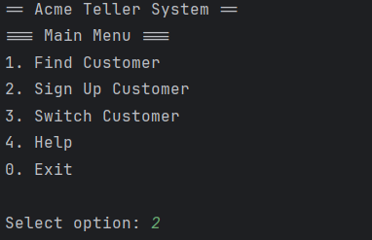
Step 2 | Continue with sign up:
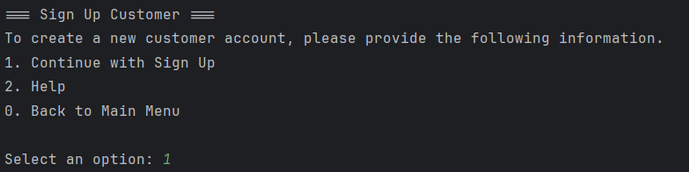
Step 3 | Inserting customer name and nation id number:
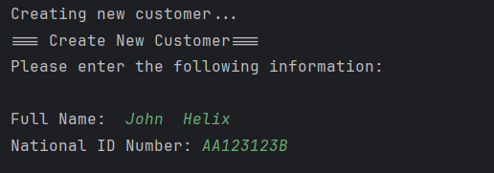
Step 4 | Selecting passport and inserting photo id number:
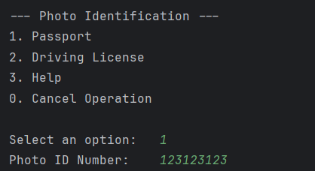
Step 5 | Selecting utility bill reference number:
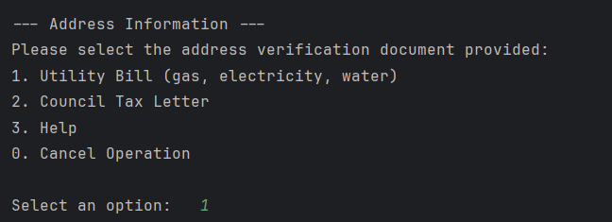
Step 6 | Entering null value:
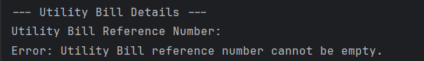
Step 7 | Entering a single character:
Step 8 | Entering correctly formatted reference number:
Step 9 | Viewing program accepting correct formatted reference number:
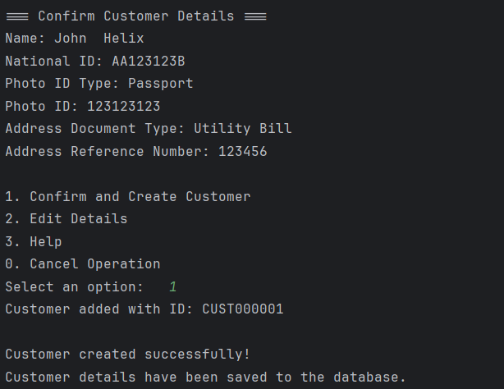
Test number 2
Step 1 | Opening logs.txt file:

Step 2 | Viewing the logs:
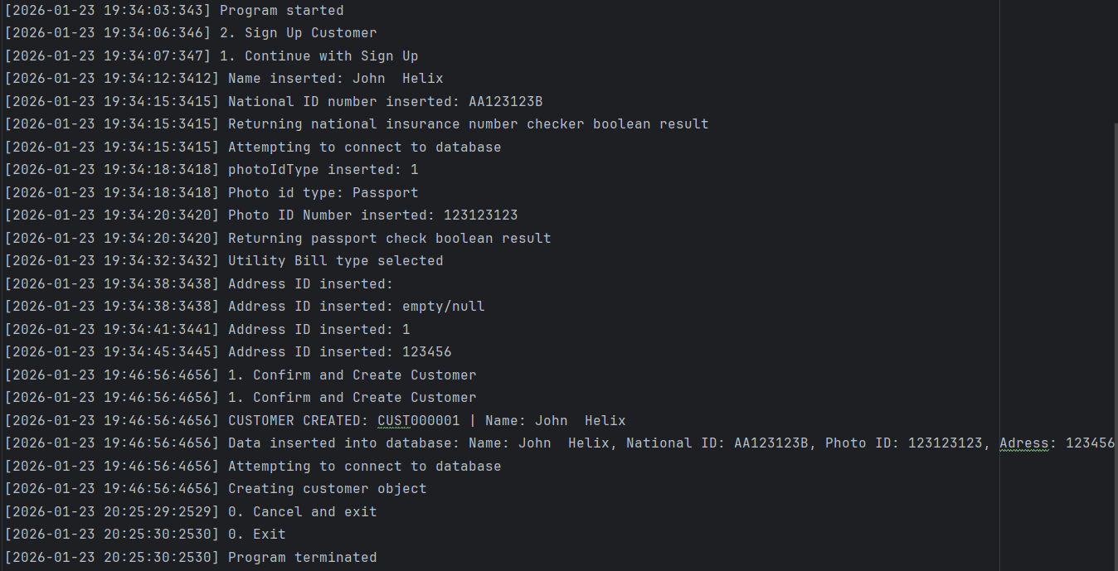
Test number 3
Step 1 | Finding/Loading customer “John Helix”:
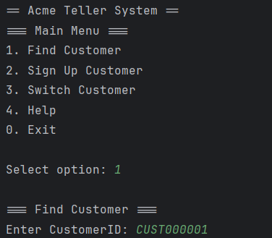
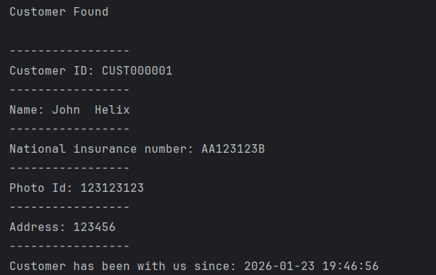
Step 2 | Open account:
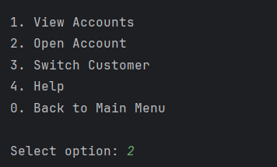

Step 3 | Selecting to open personal account:
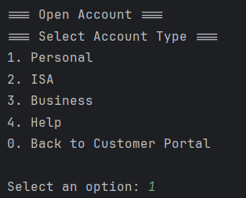

Step 4 | Setting initial balance to £20 and confirming creation:
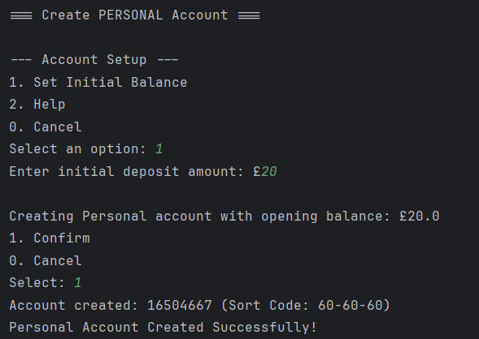
Step 5| Open account:
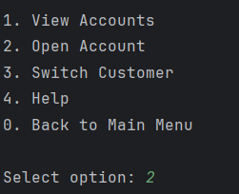
Step 6 | Selecting to open personal account:
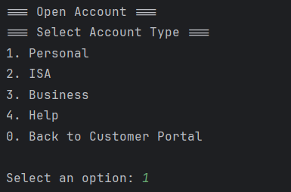
Step 7| Setting initial balance to £35 and confirming creation:
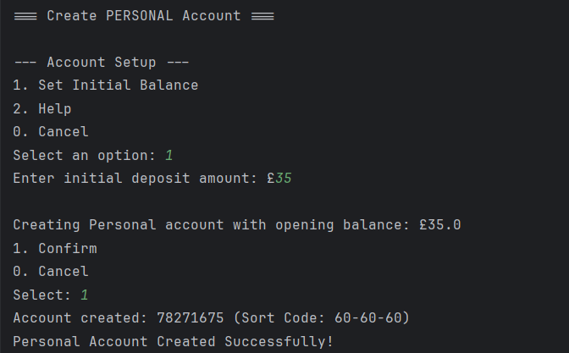
Step 8 | Open account:
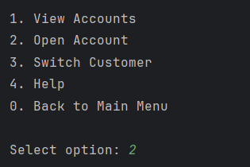
Step 9 | Selecting to open ISA account:
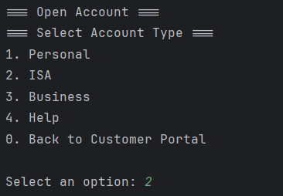
Step 10 | Setting initial balance to £500 and confirming creation:
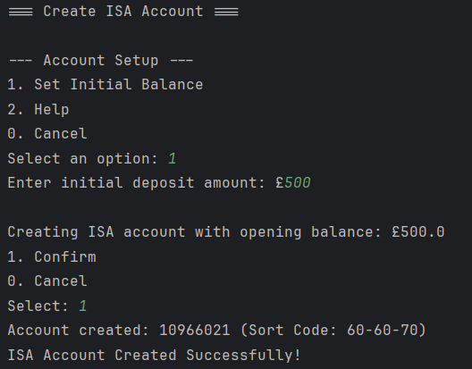
Step 11 | Selecting view accounts option:
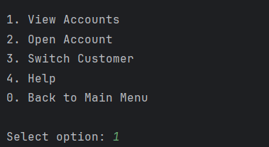
Step 12 | Viewing all accounts:
